Problem Statement
Using ATP men’s tennis statistics (2009–2017, 1 721 player-year records) we want to understand which on-court performance metrics best predict career outcomes—especially yearly Winnings, Wins and Ranking. The practical goal is to build and compare linear regression models that range from a single feature to multi-feature specifications, quantify predictive power (R²), and explore model stability under resampling and noise.

Solution Strategy
1. Load & profile the data (no missing values). 2. Exploratory scatter plots + correlation heatmap to surface strong linear relationships. 3. Single-feature ordinary least-squares models with train/test split; rank features by test R². 4. Systematic two-feature and multi-feature experiments. 5. Alternate implementations (scaled Pipeline, pure-NumPy OLS, target = Wins). 6. Monte-Carlo simulation that varies test size, subsample fraction and additive noise to assess R² variability. Volume statistics (games played, break-point opportunities) dominate pure percentage statistics.

Solution
Best single feature: ServiceGamesPlayed (Test R² ≈ 0.825). Strong two-feature pair: BreakPointsOpportunities + Aces (R² ≈ 0.829). Best multi-feature set (mixed volume + quality) reaches Test R² ≈ 0.831. Volume-only set is nearly as good (0.827). Percentage-only features yield only ~0.23. Ranking is harder to predict (CV R² ~0.3). Simulation (80 bootstrap resamples) shows mean R² ≈ 0.831 with std ≈ 0.031 under default settings—stable for full-sample models.
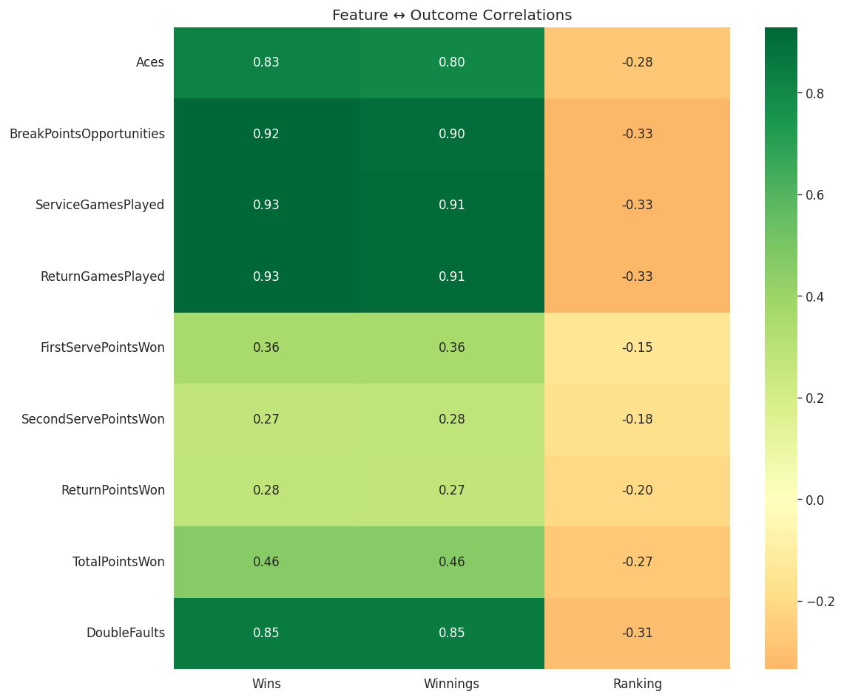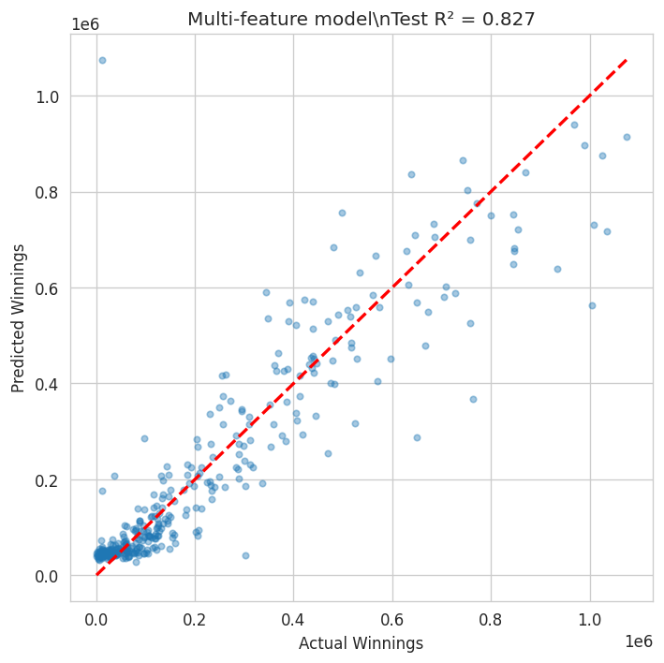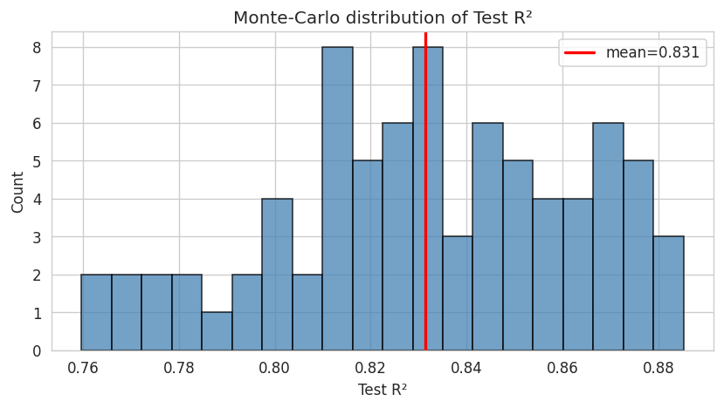
Left: feature–outcome correlations | Center: multi-feature predicted vs actual | Right: Monte-Carlo R² distribution

Key Takeaways
• Volume metrics (ServiceGamesPlayed, BreakPointsOpportunities, ReturnGamesPlayed, Aces, DoubleFaults) are by far the strongest linear predictors of yearly earnings and wins.
• A single well-chosen volume feature already explains >80 % of the variance in Winnings; additional carefully selected features yield only marginal gains.
• Pure percentage / efficiency statistics add little predictive power once volume is controlled for—consistent with the idea that top earners simply contest far more matches.
• Model performance is robust to moderate changes in train/test split; it degrades quickly under heavy target noise or extreme data subsampling (shown in the simulation section).
• Practical implication: career longevity and match volume are tightly coupled with prize-money success on the ATP tour.

